**PRACTICAL - 8**

**AIM: To apply the concept of Aggregating Data using Group functions.**

**QUERIES:**

**(1) List total deposit of customer having account date after 1-jan-96.**

SELECT SUM(AMOUNT) FROM DEPOSIT1 WHERE ADATE > '1-JAN-96'

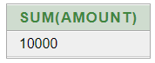

**(2) List total deposit of customers living in city Nagpur.**SELECT SUM(AMOUNT) FROM DEPOSIT1 NATURAL JOIN BRANCH WHERE CITY='NAGPUR';

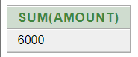

**(3) List maximum deposit of customers living in bombay.**SELECT SUM(AMOUNT) FROM DEPOSIT1 NATURAL JOIN BRANCH WHERE CITY='BOMBAY';

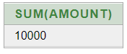

**(4) Display the highest, lowest, sum, and average salary of all employees. Label the columns Maximum, Minimum, Sum, and Average, respectively. Round your results to the nearest whole number.**SELECT MAX (EMP_SAL) "MAXIMUM" ,MIN(EMP_SAL) "MINIMUM",SUM(EMP_SAL) "SUM", AVG (EMP_SAL) "AVERAGE" FROM EMPLOYEE;

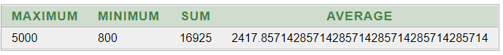

**(5) Write a query that displays the difference between the highest and lowest salaries. Label the column DIFFERENCE.**SELECT MAX(EMP_SAL)-MIN(EMP_SAL) "DIFFERENCE" FROM EMPLOYEE; 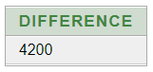

**(6) Create a query that will display the total number of employees and, of that total, the number of employees hired in 1995, 1996, 1997, and 1998**SELECT COUNT (EMP_NO) FROM EMPLOYEE;

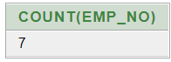

**(7) Find the average salaries for each department without displaying the respective department numbers.**SELECT AVG(EMP_SAL) FROM EMPLOYEE GROUP BY DEPT_NO;

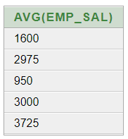

**(8) Write a query to display the total salary being paid to each job title, within each department.**SELECT DEPT_NO,SUM(EMP_SAL) FROM EMPLOYEE GROUP BY DEPT_NO;

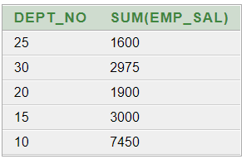

**(9) Find the average salaries > 2000 for each department without displaying the respective department numbers.**

SELECT AVG(EMP_SAL) FROM EMPLOYEE GROUP BY DEPT_NO HAVING AVG(EMP_SAL)> 2000; 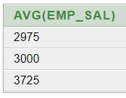

**(10) Display the job and total salary for each job with a total salary amount exceeding 3000 and sorts the list by the total salary.**SELECT DEPT_NO,SUM(EMP_SAL) FROM EMPLOYEE GROUP BY DEPT_NO HAVING SUM(EMP_SAL) > 3000 ORDER BY SUM(EMP_SAL);

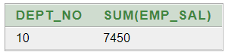

**(11) List the branches having sum of deposit more than 5000 and located in city bombay.**

SELECT BNAME FROM DEPOSIT1 NATURAL JOIN BRANCH GROUP BY BNAME HAVING SUM(AMOUNT)>5000;

